LAB MANUAL

POWER SYSTEM MODELING & SIMULATION LAB

(IV B. Tech VI Semester EE)



DEPARTMENT OF ELECTRICAL ENGINEERING

LIST OF EXPERIMENTS

Simulate Swing Equation in Simulink (MATLAB)
- Modeling of Synchronous Machine.

- Modeling of Induction Machine.
- Simulate simple circuits using Circuit Maker.

- (A) Modeling of Synchronous Machine with PSS.

  - Simulation of Synchronous Machine with FACTS device.

- (A) Modeling of Synchronous Machine with FACTS device.

  - Simulation of Synchronous Machine with FACTS devices.

- FACTS Controller designs with FACT devices for SMIB system.

EXPERIMENT NO. 1

Aim: - Simulate Swing Equation in Simulink (MATLAB).

Apparatus required:- MATLAB Software.

Theory:-
The equation governing rotor motion of a synchronous machine is based on the elementary principle in dynamics which states that accelerating torque is the product of the moment of inertia of the rotor times its angular acceleration. In the MKS (meter-kilogram-second) system of units this equation can be written for the synchronous gene rotor in the form:
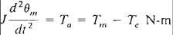
Where the symbols have the following meanings:
J = The total moment of inertia of the rotor m asses, in kg-m2
θm = the angular displacement of the rotor with respect to a stationary axis, in mechanical radians (rad)
t = time, in seconds (s)
Tm = the mechanical or shaft torque supplied by the prime mover less retarding torque due to rotational losses, i n N-m Te the net electrical or electromagnetic torque, in N-m
Ta = the net accelerating torque, in N-m.

Circuit Diagram:-

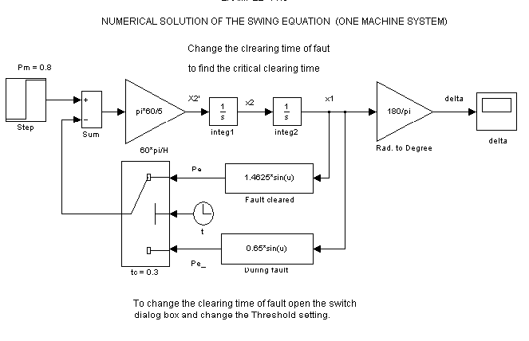

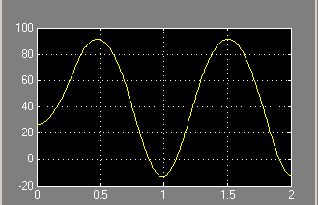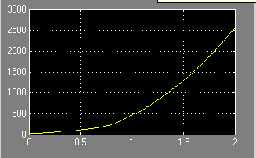

Precaution :-
- (b)

  - Swing curve for machine if fault cleared in 0.3 sec.

  - Swing curve for machine if fault cleared in 0.5 sec.

- Do not tamper with the settings of software.
- Study the all observations very carefully.

Procedure:-

Observation Table:-

Calculations:-

Result:- Simulation of Swing Equation in Simulink (MATLAB) has been done.

References:-

- http://www.mathworks.in/matlabcentral/newsreader/view_thread/23445
- http://seminarprojects.net/q/simulate-swing-equation-in-simulink-matlab

Viva voice Question:-

Q. 1 What is swing equation?

Q. 2 What is equal area criteria?

EXPERIMENT NO. 2

Aim:- Modeling of Synchronous Machine.

Apparatus Required:- MATLAB software.

Theory:-

The Synchronous Machine block operates in generator or motor modes. The operating mode is dictated by the sign of the mechanical power (positive for generator mode, negative for motor mode). The electrical part of the machine is represented by a sixth-order state-space model and the mechanical part is the same as in the Simplified Synchronous Machine block.

The model takes into account the dynamics of the stator, field, and damper windings. The equivalent circuit of the model is represented in the rotor reference frame (qd frame). All rotor parameters and electrical quantities are viewed from the stator. They are identified by primed variables. The subscripts used are defined as follows:

- d,q: d and q axis quantity
- R,s: Rotor and stator quantity
- l,m: Leakage and magnetizing inductance
- f,k: Field and damper winding quantity The electrical model of the machine is
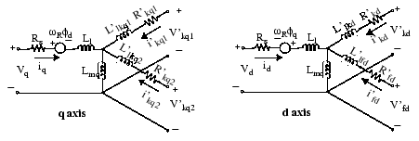

with the following equations.

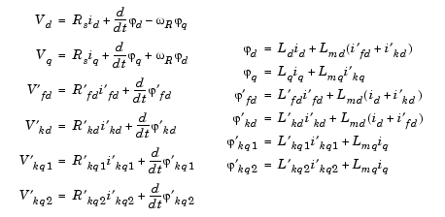

Note that this model assumes currents flowing into the stator windings. The measured stator currents returned by the Synchronous Machine block (Ia, Ib, Ic, Id, Iq) are the currents flowing out of the machine.

Dialog Box and Parameters:- In the powerlib library you can choose between three Synchronous Machine blocks to specify the parameters of the model. They simulate exactly the same synchronous machine model; the only difference is the way of entering the parameter units in the Parameters tab.

Preset model:- Provides a set of predetermined electrical and mechanical parameters for various synchronous machine ratings of power (kVA), phase-to-phase voltage (V), frequency (Hz), and rated speed (rpm).
Select one of the preset models to load the corresponding electrical and mechanical parameters in the entries of the dialog box. Select No if you do not want to use a preset model, or if you want to modify some of the parameters of a preset model, as described below.
When you select a preset model, the electrical and mechanical parameters in the Parameters tab of the dialog box become unmodifiable (grayed out). To start from a given preset model and then modify machine parameters, you have to do the following:
- Select the desired preset model to initialize the parameters.
- Change the Preset model parameter value to No. This will not change the machine parameters. By doing so, you just break the connection with the particular preset model.
- Modify the machine parameters as you wish, then click Apply.

Mechanical input:- Allows you to select either the torque applied to the shaft or the rotor speed as the Simulink signal applied to the block's input.
Select Mechanical power Pm to specify a mechanical power input, in W or in pu, and change labeling of the block's input to Pm. The machine speed is determined by the machine Inertia J (or inertia constant H for the pu machine) and by the difference between the mechanical torque Tm, resulting from the the applied mechanical power Pm, and the internal electromagnetic torque Te. The sign convention for the mechanical power is the following: when the speed is positive, a positive mechanical power signal indicates generator mode and a negative signal indicates motor mode.

Select Speed w to specify a speed input, in rad/s or in pu, and change labeling of the block's input to
w. The machine speed is imposed and the mechanical part of the model (inertia constant H) is ignored. Using the speed as the mechanical input allows modeling a mechanical coupling between two machines and interfacing with SimMechanics and SimDriveline models.
The next figure indicates how to model a stiff shaft interconnection in a motor-generator set, where both machines are synchronous machines.
The speed output of machine 1 (motor) is connected to the speed input of machine 2 (generator). In this figure friction torque is ignored in machine 2. Therefore, its electromagnetic torque output Te corresponds to the mechanical torque Tm applied to the shaft of machine 1. The corresponding mechanical input power of machine 1 is computed as Pm = Tm*w.The Kw factor takes into account speed units of both machines (pu or rad/s) and gear box ratio w2/w1. The KT factor takes into account torque units of both machines (pu or N.m) and machine ratings. Also, as the inertia J2 is ignored in machine 2, J2 referred to machine 1 speed must be added to machine 1 inertia J1.
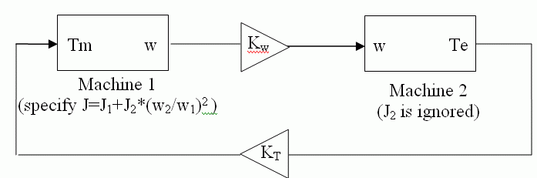

Rotor type:- Specify rotor type: Salient-pole or Round (cylindrical). This choice affects the number of rotor circuits in the q-axis (damper windings).

Mask units:- Specifies the units of the electrical and mechanical parameters of the model. This parameter is not modifiable; it is provided for information purposes only.

Nominal power, voltage, frequency, field current:- The total three-phase apparent power Pn (VA), RMS line-to-line voltage Vn (V), frequency fn (Hz), and field current ifn (A).The nominal field current is the current that produces nominal terminal voltage under no-load conditions. This model was developed with all quantities viewed from the stator. The nominal field current makes it possible to compute the transformation ratio of the machine, which allows you to apply the field voltage viewed from the rotor, as in real life. This also allows the field current, which is a variable in the output vector of the model, to be viewed from the rotor. If the value of the nominal field current is not known, you must enter 0 or leave it blank. Since the transformation ratio cannot be determined in this case, you have to apply the field voltage as viewed from the stator and the field current in the output vector is also viewed from the stator.

Stator:- The resistance Rs (Ω), leakage inductance Lls (H), and d-axis and q-axis magnetizing inductances Lmd (H) and Lmq (H).

Field:- The field resistance Rf' (Ω) and leakage inductance Llfd' (H), both referred to the stator.

Dampers:- The d-axis resistance Rkd' (Ω) and leakage inductance Llkd' (H), the q-axis resistance Rkq1' (Ω) and leakage inductance Llkq1' (H), and (only if round rotor) the q-axis resistance Rkq2' (Ω) and leakage inductance Llkq2' (H). All these values are referred to the stator.

Inertia, friction factor, pole pairs:- The inertia coefficient J (kg.m2), friction factor F (N.m.s), and number of pole pairs p. The friction torque Tf is proportional to the rotor speed ω (Tf = F.ω, where Tf is expressed in N.m, F in N.m.s, and ω in rad/s).

Initial conditions:- The initial speed deviation Δω (% of nominal speed), electrical angle of the rotor Θe (degrees), line current magnitudes ia, ib, ic (A) and phase angles pha, phb, phc (degrees), and the initial field voltage Vf (V).You can specify the initial field voltage in one of two ways. If

you know the nominal field current (first line, last parameter), enter in the dialog box the initial field voltage in volts DC referred to the rotor. Otherwise, enter a zero as nominal field current, as explained earlier, and specify the initial field voltage in volts DC referred to the stator. You can determine the nominal field voltage viewed from the stator by selecting the Display Vfd which produces a nominal Vt check box at the bottom of the dialog box.

Simulate saturation:- Specifies whether magnetic saturation of rotor and stator iron is to be simulated or not.
Saturation parameters:- The no-load saturation curve parameters. Magnetic saturation of stator and rotor iron is modeled by a nonlinear function (in this case a polynomial) using points on the no-load saturation curve. You must enter a 2-by-n matrix, where n is the number of points taken from the saturation curve. The first row of this matrix contains the values of field currents, while the second row contains values of corresponding terminal voltages. The first point (first column of the matrix) must correspond to the point where the effect of saturation begins.

You must select the Simulate saturation check box to simulate saturation. This check box allows you to enter the matrix of parameters for simulating the saturation. If you do not want to model saturation in your simulation, do not select the Simulate saturation check box. In this case the relationship between ifd and Vt obtained is linear (no saturation).

Nominal power, line-to-line voltage, and frequency:- Total three-phase apparent power (VA), RMS line-to-line voltage (V), frequency (Hz), and field current (A).This line is identical to the first line of the fundamental parameters in SI dialog box, except that you do not specify a nominal field current. This value is not required here because we do not need the transformation ratio. Since rotor quantities are viewed from the stator, they are converted to pu using the stator base quantities derived from the preceding three nominal parameters.

Stator; Field; Dampers:- Contain exactly the same parameters as in the previous dialog box, but they are expressed here in pu instead of SI units.

Inertia coefficient, friction factor, pole pairs:- The inertia constant H (s), where H is the ratio of energy stored in the rotor at nominal speed over the nominal power of the machine, the friction

factor F (pu torque/pu speed), and the number of pole pairs p. The friction torque Tf is proportional to the rotor speed ω (Tf=F.ω, where all quantities are expressed in pu).

Initial conditions; Simulate saturation; Saturation parameters: The same initial conditions and saturation parameters as in the SI units dialog box, but all values are expressed in pu instead of SI units. For saturation, the nominal field current multiplied by the d-axis magnetizing inductance and nominal RMS line-to-line voltage are the base values for the field current and terminal voltage, respectively.

Nominal power, line-to-line voltage, and frequency:- The same parameters as in the pu Fundamental dialog box.
Reactances:- The d-axis synchronous reactance Xd, transient reactance Xd', and subtransient reactance Xd'', the q-axis synchronous reactance Xq, transient reactance Xq' (only if round rotor), and subtransient reactance Xq'', and finally the leakage reactance Xl (all in pu).

xis time constants; q-axis time constant(s)
Specify the time constants you supply for each axis: either open-circuit or short-circuit.

Time constants:- The d-axis and q-axis time constants (all in s). These values must be consistent with choices made on the two previous lines: d-axis transient open-circuit (Tdo') or short-circuit (Td') time constant, d-axis subtransient open-circuit (Tdo'') or short-circuit (Td'') time constant, q- axis transient open-circuit (Tqo') or short-circuit (Tq') time constant (only if round rotor), q-axis subtransient open-circuit (Tqo'') or short-circuit (Tq'') time constant.
Saturation is modeled by fitting a polynomial to the curve corresponding to the matrix of points you enter. The more points you enter, the better the fit to the original curve.The next figure illustrates the good fit graphically (the diamonds are the actual points entered in the dialog box).In this particular case, the following values were used:

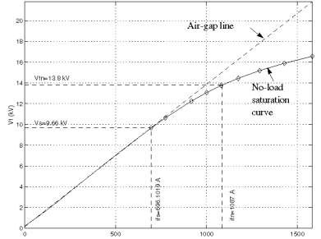

ifn 1087 A

ifd [695.64, 774.7, 917.5, 1001.6, 1082.2, 1175.9, 1293.6, 1430.2, 1583.7] A

Vt [9660, 10623, 12243, 13063, 13757, 14437, 15180, 15890, 16567] V

Sample time (-1 for inherited)

Specifies the sample time used by the block. To inherit the sample time specified in the Powergui block, set this parameter to -1.

Inputs and Outputs:- The units of inputs and outputs vary according to which dialog box was used to enter the block parameters. If the fundamental parameters in SI units is used, the inputs and outputs are in SI units (except for dw in the vector of internal variables, which is always in pu, and angle Θ, which is always in rad). Otherwise, the inputs and outputs are in pu.

Pm:- The first Simulink input is the mechanical power at the machine's shaft. In generating mode, this input can be a positive constant or function or the output of a prime mover block (see the Hydraulic Turbine and Governor or Steam Turbine and Governor blocks). In motoring mode, this input is usually a negative constant or function.

w:- The alternative block input instead of Pm (depending on the value of the Mechanical input
parameter) is the machine speed, in rad/s.

Vf:- The second Simulink input of the block is the field voltage. This voltage can be supplied by a voltage regulator in generator mode (see the Excitation System block). It is usually a constant in motor mode. If you use the model in SI fundamental units, the field voltage Vf should be entered in volts DC if nominal field current Ifn is specified or in volts referred to stator if Ifn is not specified.
To obtain the Vfd producing nominal voltage, select the last check box of the dialog box. you use
If
the model in pu Standard or in pu Fundamental units, Vf should be entered in pu (1 pu of field voltage producing 1 pu of terminal voltage at no load).

M:- The Simulink output of the block is a vector containing 22 signals. You can demultiplex these signals by using the Bus Selector block provided in the Simulink library.

Signal | Definition | Units
1 | Stator current is_a | A or pu
2 | Stator current is_b | A or pu
3 | Stator current is_c | A or pu
4 | Stator current is_q | A or pu
5 | Stator current is_d | A or pu
6 | Field current ifd | A or pu
7 | Damper winding current ikq1 | A or pu
8 | Damper winding current ikq2 | A or pu
9 | Damper winding current ikd | A or pu
10 | Mutual flux phimq | V.s or pu
11 | Mutual flux phimd | V.s or pu
12 | Stator voltage vq | V or pu

Signal | Definition | Units
13 | Stator voltage vd | V or pu
14 | Rotor angle deviation d_theta | rad
15 | Rotor speed wm | rad/s.
16 | Electrical power Pe | VA or pu
17 | Rotor speed deviation dw | rad/s
18 | Rotor mechanical angle theta | rad
19 | Electromagnetic torque Te | N.m or pu
20 | Load angle delta | N.m or pu
21 | Output active power Peo | rad
22 | Output reactive power Qeo | rad

Limitations

When you use Synchronous Machine blocks in discrete systems, you might have to use a small parasitic resistive load, connected at the machine terminals, in order to avoid numerical oscillations. Large sample times require larger loads. The minimum resistive load is proportional to the sample time. As a rule of thumb, remember that with a 25 μs time step on a 60 Hz system, the minimum load is approximately 2.5% of the machine nominal power. For example, a 200 MVA synchronous machine in a power system discretized with a 50 μs sample time requires approximately 5% of resistive load or 10 MW. If the sample time is reduced to 20 μs, a resistive load of 4 MW should be sufficient.

Circuit Diagram:-

Precaution:-

    - Do not tamper with the settings of software.
    - Study the all observations very carefully.

Procedure:-

Observation Table:-

Calculations:-

Results:- We have successfully Modelled of Synchronous Machine.

References:-

- http://www.mathworks.in/matlabcentral/newsreader/about
- http://www.mathworks.in/matlabcentral/newsreader/view_thread/336143

Viva- Voice:-

What is Synchronous Machine?

What is Synchronous Machine Speed?

EXPERIMENT NO. 3

Aim:- Modeling of Induction Machine.
Apparatus Required:- MATLAB Software

Theory:-

The Asynchronous Machine block operates in either generator or motor mode. The mode of operation is dictated by the sign of the mechanical torque:

    - If Tm is positive, the machine acts as a motor.
    - If Tm is negative, the machine acts as a generator.

The electrical part of the machine is represented by a fourth-order state-space model and the mechanical part by a second-order system. All electrical variables and parameters are referred to the stator. This is indicated by the prime signs in the machine equations given below. All stator and rotor quantities are in the arbitrary two-axis reference frame (dq frame). The subscripts used are defined as follows:

Subscript | Definition
d | d axis quantity
q | q axis quantity
r | Rotor quantity
s | Stator quantity
l | Leakage inductance
m | Magnetizing inductance

Electrical System

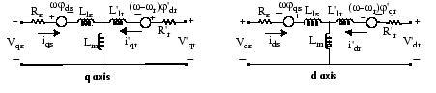
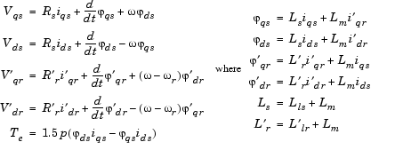

Mechanical System

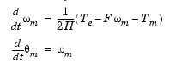

The Asynchronous Machine block parameters are defined as follows (all quantities are referred to the stator):

Parameter | Definition
Rs, Lls | Stator resistance and leakage inductance
R'r, L'lr | Rotor resistance and leakage inductance
Lm | Magnetizing inductance
Ls, L'r | Total stator and rotor inductances

Parameter | Definition
Vqs, iqs | q axis stator voltage and current
V'qr, i'qr | q axis rotor voltage and current
Vds, ids | d axis stator voltage and current
V'dr, i'dr | d axis rotor voltage and current
ϕqs, ϕds | Stator q and d axis fluxes
ϕ'qr, ϕ'dr | Rotor q and d axis fluxes
ωm | Angular velocity of the rotor
Θm | Rotor angular position
p | Number of pole pairs
ωr | Electrical angular velocity (ωm x p)
Θr | Electrical rotor angular position (Θm x p)
Te | Electromagnetic torque
Tm | Shaft mechanical torque
J | Combined rotor and load inertia coefficient. Set to infinite to simulate locked rotor.
H | Combined rotor and load inertia constant. Set to infinite to simulate locked rotor.
F | Combined rotor and load viscous friction coefficient

Dialog Box and Parameters

You can choose between two Asynchronous Machine blocks to specify the electrical and mechanical parameters of the model, by using the pu Units dialog box or the SI dialog box. Both blocks are modeling the same asynchronous machine model. Depending on the dialog box you choose to use, SimPowerSystems™ software automatically converts the parameters you enter into per unit parameters. The Simulink® model of the Asynchronous Machine block uses pu parameters.

Configuration Tab

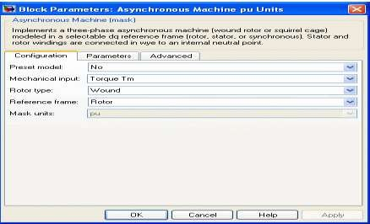

Preset model:- Provides a set of predetermined electrical and mechanical parameters for various asynchronous machine ratings of power (HP), phase-to-phase voltage (V), frequency (Hz), and rated speed (rpm).

Select one of the preset models to load the corresponding electrical and mechanical parameters in the entries of the dialog box. Note that the preset models do not include predetermined saturation parameters. Select No if you do not want to use a preset model, or if you want to modify some of the parameters of a preset model, as described below.

When you select a preset model, the electrical and mechanical parameters in the Parameters tab of the dialog box become unmodifiable (grayed out). To start from a given preset model and then modify machine parameters, you have to do the following:

- Select the desired preset model to initialize the parameters.
- Change the Preset model parameter value to No. This will not change the machine parameters. By doing so, you just break the connection with the particular preset model.
- Modify the machine parameters as you wish, then click Apply.

Mechanical input:- Allows you to select either the torque applied to the shaft or the rotor speed as the Simulink signal applied to the block's input.

Select Torque Tm to specify a torque input, in N.m or in pu, and change labeling of the block's input to Tm. The machine speed is determined by the machine Inertia J (or inertia constant H for the pu machine) and by the difference between the applied mechanical torque Tm and the internal electromagnetic torque Te. The sign convention for the mechanical torque is the following: when the speed is positive, a positive torque signal indicates motor mode and a negative signal indicates generator mode.

Select Speed w to specify a speed input, in rad/s or in pu, and change labeling of the block's input to
w. The machine speed is imposed and the mechanical part of the model (Inertia J) is ignored. Using the speed as the mechanical input allows modeling a mechanical coupling between two machines and interfacing with SimMechanics™ and SimDriveline™ models.

The next figure indicates how to model a stiff shaft interconnection in a motor-generator set when friction torque is ignored in machine 2. The speed output of machine 1 (motor) is connected to the speed input of machine 2 (generator), while machine 2 electromagnetic torque output Te is applied to the mechanical torque input Tm of machine 1. The Kw factor takes into account speed units of both machines (pu or rad/s) and gear box ratio w2/w1. The KT factor takes into account torque units of both machines (pu or N.m) and machine ratings. Also, as the inertia J2 is ignored in machine 2, J2 referred to machine 1 speed must be added to machine 1 inertia J1.
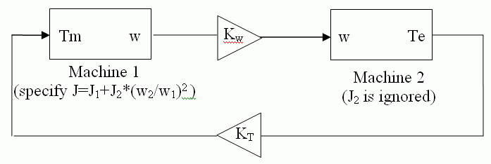

Rotor type:- Specifies the branching for the rotor windings.

Reference frame:- Specifies the reference frame that is used to convert input voltages (abc reference frame) to the dq reference frame, and output currents (dq reference frame) to the abc reference frame. You can choose among the following reference frame transformations:

- Rotor (Park transformation)
- Stationary (Clarke or αβ transformation)
- Synchronous

The following relationships describe the abc-to-dq reference frame transformations applied to the Asynchronous Machine phase-to-phase voltages.
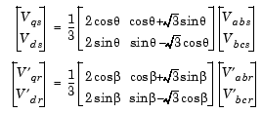

In the preceding equations, Θ is the angular position of the reference frame, while is the difference between the position of the reference frame and the position (electrical) of the rotor. Because the machine windings are connected in a three-wire Y configuration, there is no homopolar (0) component. This also justifies the fact that two line-to-line input voltages are used inside the model instead of three line-to-neutral voltages. The following relationships describe the dq-to-abc reference frame transformations applied to the Asynchronous Machine phase currents.

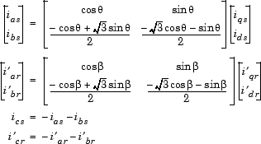

The following table shows the values taken by Θ and β in each reference frame (Θe is the position of the synchronously rotating reference frame).
Reference Frame | Θ | β
Rotor | Θr | 0
Stationary | 0 | -Θr
Synchronous | Θe | Θe -

Parameters Tab

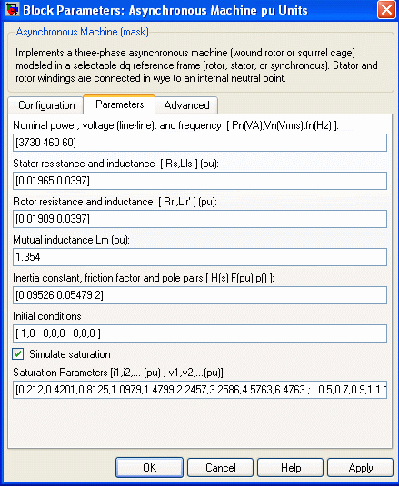

Inputs and Outputs

Tm:- The Simulink input of the block is the mechanical torque at the machine's shaft. When the input is a positive Simulink signal, the asynchronous machine behaves as a motor. When the input is a negative signal, the asynchronous machine behaves as a generator.

When you use the SI parameters mask, the input is a signal in N.m, otherwise it is in pu.

W:- The alternative block input (depending on the value of the Mechanical input parameter) is the machine speed, in rad/s.
M:- The Simulink output of the block is a vector containing 21 signals. You can demultiplex these signals by using the Bus Selector block provided in the Simulink library. Depending on the type of mask you use, the units are in SI, or in pu.
Signa | Definition | Units | Symbo
1 | Rotor current ir_a | A or pu | i'ra
2 | Rotor current ir_b | A or pu | i'rb
3 | Rotor current ir_c | A or pu | i'rc
4 | Rotor current iq | A or pu | i'qr
5 | Rotor current id | A or pu | i'dr
6 | Rotor flux phir_q | V.s or pu | ϕ'qr
7 | Rotor flux phir_d | V.s or pu | ϕ'dr
8 | Rotor voltage Vr_q | V or pu | v'qr
9 | Rotor voltage Vr_d | V or pu | v'd
10 | Stator current is_a | A or pu | isa
11 | Stator current is_b | A or pu | isb
12 | Stator current is_c | A or pu | isc
13 | Stator current is_q | A or pu | iqs
14 | Stator current is_d | A or pu | ids

Signa | Definition | Units | Symbo
15 | Stator flux phis_q | V.s or pu | ϕqs
16 | Stator flux phis_d | V.s or pu | ϕds
17 | Stator voltage vs_q | V or pu | vqs
18 | Stator voltage vs_d | V or pu | vds
19 | Rotor speed | rad/s | ωm
20 | Electromagnetic torque Te | N.m or pu | Te
21 | Rotor angle thetam | rad | Θm

The stator terminals of the Asynchronous Machine block are identified by the A, B, and C letters. The rotor terminals are identified by the a, b, and c letters. Note that the neutral connections of the stator and rotor windings are not available; three-wire Y connections are assumed.

Limitations

- The Asynchronous Machine block does not include a representation of the saturation of leakage fluxes. You must be careful when you connect ideal sources to the machine's stator. If you choose to supply the stator via a three-phase Y-connected infinite voltage source, you must use three sources connected in Y. However, if you choose to simulate a delta source connection, you must use only two sources connected in series.

- When you use Asynchronous Machine blocks in discrete systems, you might have to use a small parasitic resistive load, connected at the machine terminals, in order to avoid numerical oscillations. Large sample times require larger loads. The minimum resistive load is proportional to the sample time. As a rule of thumb, remember that with a 25 μs time step on a 60 Hz system, the minimum load is approximately 2.5% of the machine nominal power. For example, a 200 MVA asynchronous machine in a power system discretized with a 50 μs sample time requires approximately 5% of resistive load or 10 MW. If the sample time is reduced to 20 μs, a resistive load of 4 MW should be sufficient.

Circuit Diagram:-

Precaution:-

- Do not tamper with the settings of software.
- Study the all observations very carefully.

Procedure:-

Observation Table:-

Calculations:-

Results:- We have successfully Modelled the Induction Machine.

References:-

- http://www.mathworks.in/matlabcentral/newsreader/view_thread/336140
- http://seminarprojects.net/q/simulate-swing-equation-in-simulink-matlab

Viva- Voice:-

What is Induction Machine?

EXPERIMENT NO. 4

Aim:- Simulate simple circuits using Circuit Maker.

Apparatus Required:- MATLAB Software.

Theory:-

Create the Simple Model:

Before you can begin building your model, you must start Simulink and create an empty model. To create a new model:
    - If Simulink is not running, enter simulink in the MATLAB Command Window to open the Simulink Library Browser.
    - Select File > New > Model in the Simulink Library Browser to create a new model.

The software opens an empty model window.
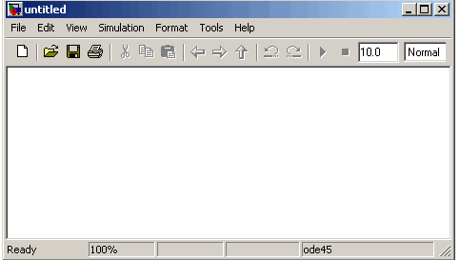

Adding Blocks to Your Model

To construct a model, you first copy blocks from the Simulink Library Browser to the model window. To create the simple model in this chapter, you need four blocks:

- Sine Wave — To generate an input signal for the model
- Integrator — To process the input signal
- Scope — To visualize the signals in the model
- Mux — To multiplex the input signal and processed signal into a single scope

To add blocks to your model:

- Select the Sources library in the Simulink Library Browser.

The Simulink Library Browser displays the Sources library.
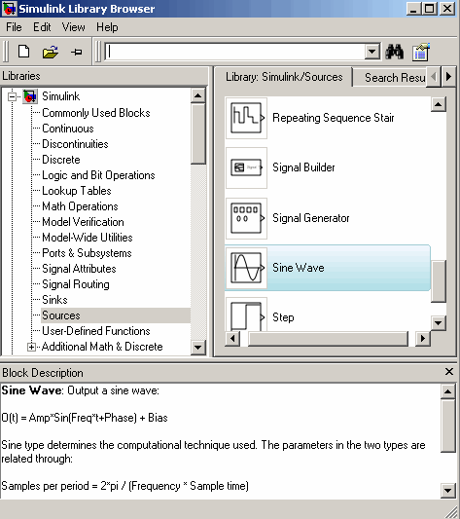

- Select the Sine Wave block in the Simulink Library Browser, then drag it to the model window. A copy of the Sine Wave block appears in the model window.
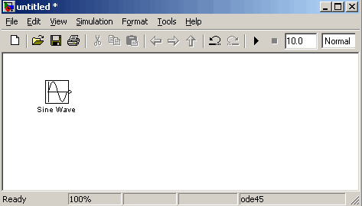

- Select the Sinks library in the Simulink Library Browser.
- Select the Scope block from the Sinks library, then drag it to the model window.

A Scope block appears in the model window.

- Select the Continuous library in the Simulink Library Browser.
- Select the Integrator block from the Continuous library, then drag it to the model window.

An Integrator block appears in the model window.

- Select the Signal Routing library in the Simulink Library Browser.
- Select the Mux block from the Sinks library, then drag it to the model window.

A Mux block appears in the model window.

Moving Blocks in the Model Window

Before you connect the blocks in your model, you should arrange them logically to make the signal connections as straightforward as possible.

To move a block in the model window, you can either:

- Drag the block.
- Select the block, then press the arrow keys on the keyboard.

Arrange the blocks in the model to look like the following figure.

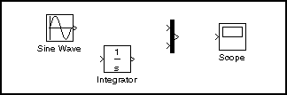

Connecting Blocks in the Model Window

After you add blocks to the model window, you must connect them to represent the signal connections within the model.

Notice that each block has angle brackets on one or both sides. These angle brackets represent input and output ports:

- The > symbol pointing into a block is an input port.
- The > symbol pointing out of a block is an output port.
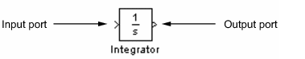

The following sections describe how to connect blocks by drawing lines from output ports to input ports:

- Drawing Lines Between Blocks
- Drawing a Branch Line

Drawing Lines Between Blocks

You connect the blocks in your model by drawing lines between output ports and input ports. To draw a line between two blocks:
- Position the mouse pointer over the output port on the right side of the Sine Wave block.

Note that the pointer changes to a crosshairs (+) shape while over the port.

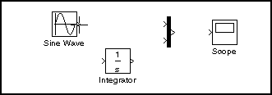

- Drag a line from the output port to the top input port of the Mux block.

Note that the line is dashed while you hold the mouse button down, and that the pointer changes to a double-lined crosshairs as it approaches the input port of the Mux block.
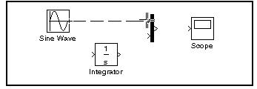

- Release the mouse button over the output port.

The software connects the blocks with an arrow that indicates the direction of signal flow.
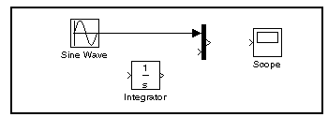

- Drag a line from the output port of the Integrator block to the bottom input port on the Mux block.

The software connects the blocks.

- Select the Mux block, then Ctrl+click the Scope block.

The software automatically draws the connection line between the blocks.

The model should now look similar to the following figure.

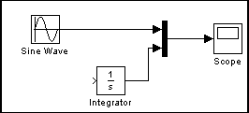

Drawing a Branch Line

The model is almost complete, but one connection is missing. To finish the model, you must connect the Sine Wave block to the Integrator block.

This final connection is somewhat different from the other three, which all connect output ports to input ports. Because the output port of the Sine Wave block already has a connection, you must connect this existing line to the input port of the Integrator block. The new line, called a branch line, carries the same signal that passes from the Sine Wave block to the Mux block.

To weld a connection to an existing line:

- Position the mouse pointer on the line between the Sine Wave and the Mux block.
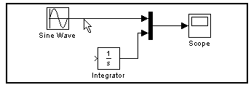

- Press and hold the Ctrl key, then drag a line to the Integrator block's input port.
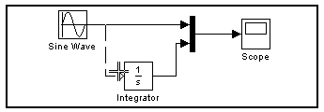

The software draws a line between the starting point and the input port of the Integrator block.

The model is now complete. It should look similar to the following figure.

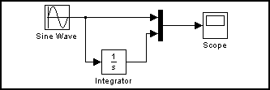

Saving the Model
After you complete the model, you should save it for future use. To save the model:
- Select File > Save in the model window.
- Specify the location in which you want to save the model.
- Enter simple_model in the File name field.
- Click Save.

The software saves the model with the file name simple_model.mdl.

Circuit Diagram:-

Precaution:-

- Do not tamper with the settings of software.
- Study the all observations very carefully.

Procedure:-

Observation Table:-

Result:- We have successfully Simulate simple circuits using Circuit Maker.

References:-

  - http://seminarprojects.net/q/simulate-swing-equation-in-simulink-matlab
  - http://www.mathworks.in/matlabcentral/newsreader/view_thread/336140

Viva voice Question:-

Q. 1 How to Add a Block in Simulation Window?

Q. 2 How Save the model?

EXPERIMENT NO. 5

Aim:- (A) Modelling of Synchronous Machine with FACTS & PSS device
(B) Simulation of Synchronous Machine with FACTS devices.

Apparatus Required:- MATLAB Software.

Theory:-

UPFC (Detailed Model)

Model Description

A Unified Power Flow Controller (UPFC) is used to control the power flow in a 500 kV transmission system. The UPFC located at the left end of the 75-km line L2, between the 500 kV buses B1 and B2, is used to control the active and reactive powers flowing through bus B2 while controlling voltage at bus B1. It consists of two 100-MVA, three-level, 48-pulse GTO-based converters, one connected in shunt at bus B1 and one connected in series between buses B1 and B2. The shunt and series converters can exchange power through a DC bus. The series converter can inject a maximum of 10% of nominal line-to-ground voltage (28.87 kV) in series with line L2.

This pair of converters can be operated in three modes:

- Unified Power Flow Controller (UPFC) mode, when the shunt and series converters are interconnected through the DC bus. When the disconnect switches between the DC buses of the shunt and series converter are opened, two additional modes are available:
- Shunt converter operating as a Static Synchronous Compensator (STATCOM) controlling voltage at bus B1
- Series converter operating as a Static Synchronous Series Capacitor (SSSC) controlling injected voltage, while keeping injected voltage in quadrature with current.

The mode of operation as well as the reference voltage and reference power values can be changed by means of the “UPFC GUI” block.

The principle of operation of the harmonic neutralized converters is explained in another demo entitled “Three-phase 48-pulse GTO converter”. This demo (power_48pulsegtoconverter.mdl) is accessible in the Power Electronics Models library of demos. When the two converters are operated in UPFC mode, the shunt converter operates as a STATCOM. It controls the bus B1 voltage by controlling the absorbed or generated reactive power while also allowing active power transfer to the series converter through the DC bus. The reactive power variation is obtained by varying the DC bus voltage. The four three-level shunt converters operate at a constant conduction angle (Sigma= 180-
7.5 = 172.5 degrees), thus generating a quasi-sinusoidal 48-step voltage waveform. The first significant harmonics are the 47th and the 49th.

When operating in UPFC mode, the magnitude of the series injected voltage is varied by varying the Sigma conduction angle, therefore generating higher harmonic contents than the shunt converter. As illustrated in this demo, when the series converter operates in SSSC mode it generates a “true” 48- pulse waveform.

The natural power flow through bus B2 when zero voltage is generated by the series converter (zero voltage on converter side of the four converter transformers) is P=+870 MW and Q=-70 Mvar. In UPFC mode, both the magnitude and phase angle and the series injected voltage can be varied, thus allowing control of P and Q. The UPFC controllable region is obtained by keeping the injected voltage to its maximum value (0.1 pu) and varying its phase angle from zero to 360 degrees. To see the resulting P-Q trajectory, double click the “Show UPFC Controllable Region”. Any point located inside the PQ elliptic region can be obtained in UPFC mode.

Demonstration

- Power control in UPFC mode

Open the UPFC GUI block menu. The GUI allows you to choose the operation mode (UPFC, STATCOM or SSSC) as well as the Pref/Qref reference powers and/or Vref reference voltage

settings. Also, in order to observe the dynamic response of the control system, the GUI allows you to specify a step change of any reference value at a specific time.

Make sure that the operation mode is set to “UPFC (Power Flow Control)”. The reference active and reactive powers are specified in the last two lines of the GUI menu. Initially, Pref= +8.7 pu/100MVA (+870 MW) and Qref=-0.6 pu/100MVA (-60 Mvar). At t=0.25 sec Pref is changed to
+10 pu (+1000MW). Then, at t=0.5 sec, Qref is changed to +0.7 pu (+70 Mvar). The reference voltage of the shunt converter (specified in the 2nd line of the GUI) will be kept constant at Vref=1 pu during the whole simulation (Step Time=0.3*100> Simulation stop time (0.8 sec). When the UPFC is in power control mode, the changes in STATCOM reference reactive power and in SSSC injected voltage (specified respectively in 1st and 3rd line of the GUI) as are not used.
Run the simulation for 0.8 sec. Open the “Show Scopes” subsystem. Observe on traces 1 and 2 of the UPFC scope the variations of P and Q. After a transient period lasting approximately 0.15 sec, the steady state is reached (P=+8.7 pu; Q=-0.6 pu). Then P and Q are ramped to the new settings (P=+10 pu Q=+0.7 pu). Observe on traces 3 and 4 the resulting changes in P Q on the three transmission lines. The performance of the shunt and series converters can be observed respectively on the STATCOM and SSSC scopes. If you zoom on the first trace of the STATCOM scope, you can observe the 48-step voltage waveform Vs generated on the secondary side of the shunt converter transformers (yellow trace) superimposed with the primary voltage Vp (magenta) and the primary current Ip (cyan). The dc bus voltage (trace 2) varies in the 19kV-21kV range. If you zoom on the first trace of the SSSC scope, you can observe the injected voltage waveforms Vinj measured between buses B1 and B2.

Var control in STATCOM mode

In the GUI block menu, change the operation mode to “STATCOM (Var Control)”. Make sure that the STATCOM references values (1st line of parameters, [T1 T2 Q1 Q2]) are set to [0.3 0.5 +0.8 -
0.8 ]. In this mode, the STATCOM is operated as a variable source of reactive power. Initially, Q is set to zero, then at T1=0.3 sec Q is increased to +0.8 pu (STATCOM absorbing reactive power) and at T2=0.5 sec, Q is reversed to -0.8 pu (STATCOM generating reactive power).

Run the simulation and observe on the STATCOM scope the dynamic response of the STATCOM. Zoom on the first trace around t=0.5 sec when Q is changed from +0.8 pu to -0.8 pu. When Q=+0.8 pu, the current flowing into the STATCOM (cyan trace) is lagging voltage (magenta trace), indicating that STATCOM is absorbing reactive power. When Qref is changed from +0.8 to -0.8, the current phase shift with respect to voltage changes from 90 degrees lagging to 90 degrees leading within one cycle. This control of reactive power is obtained by varying the magnitude of the secondary voltage Vs generated by the shunt converter while keeping it in phase with the bus B1 voltage Vp. This change of Vs magnitude is performed by controlling the dc bus voltage. When Q is changing from +0.8 pu to -0.8 pu, Vdc (trace 3) increases from 17.5 kV to 21 kV.

Series voltage injection in SSSC mode
In the GUI block menu change the operation mode to “SSSC (Voltage injection)”. Make sure that the SSSC references values (3rd line of parameters) [Vinj_Initial Vinj_Final StepTime] ) are set to [0.0 0.08 0.3 ]. The initial voltage is set to 0 pu, then at t=0.3 sec it will be ramped to 0.8 pu.

Run the simulation and observe on the SSSC scope the impact of injected voltage on P and Q flowing in the 3 transmission lines. Contrary to the UPFC mode, in SSCC mode the series inverter operates with a constant conduction angle (Sigma= 172.5 degrees). The magnitude of the injected voltage is controlled by varying the dc voltage which is proportional to Vinj (3rd trace). Also, observe the waveforms of injected voltages (1st trace) and currents flowing through the SSSC (2nd trace). Voltages and currents stay in quadrature so that the SSSC operates as a variable inductance or capacitance.

Circuit Diagram:-
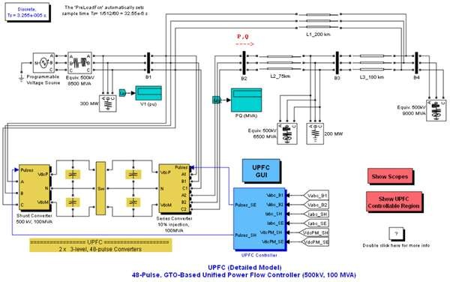

Fig:- Detailed Model of a 48-Pulse,GTO-Based Unified Power Flow Controller (500 kV, 100 MVA)

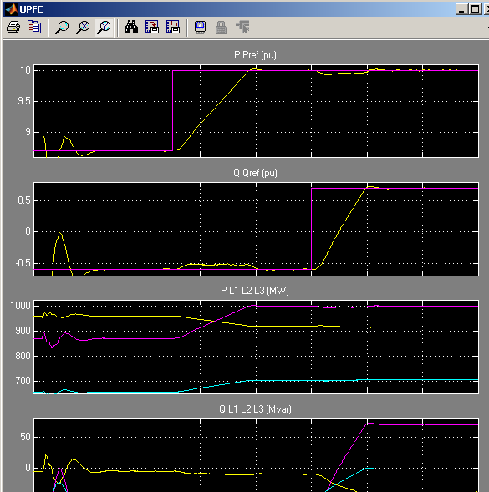

Precaution:-

  - Do not tamper with the settings of software.
  - Study the all observations very carefully.

Procedure:-

Observation Table:-

Calculations:-

Results:- We have successfully Modelied of Synchronous Machine with FACTS & PSS device and Simulate of Synchronous Machine with FACTS & PSS devices.
.

Output Wave Forms

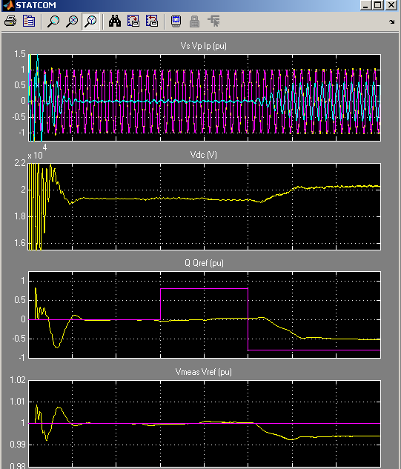

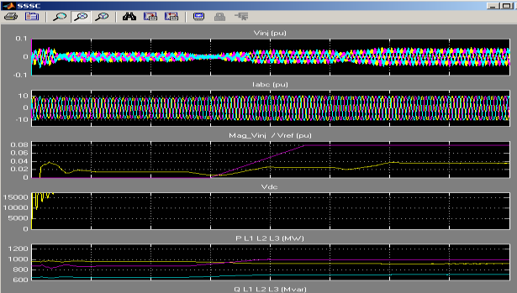

References:-

- http://www.mathworks.in/matlabcentral/newsreader/view_thread/328696
- http://seminarprojects.net/q/simulate-swing-equation-in-simulink-matlab

Viva- Voice:-

What is FACTS?

What is PSS?

EXPERIMENT NO. 6

Aim: - FACTS Controller designs with FACT devices for SMIB system.

Apparatus required:- MATLAB software.

Theory:-

A 100-Mvar STATCOM regulates voltage on a three-bus 500-kV system. The 48-pulse STATCOM uses a Voltage-Sourced Converter (VSC) built of four 12-pulse three-level GTO inverters. Look inside the STATCOM block to see how the VSC inverter is built. The four sets of three-phase voltages obtained at the output of the four three-level inverters are applied to the secondary windings of four phase-shifting transformers (-15 deg., -7.5 deg., 7.5 deg., +7.5 deg. phase shifts). The fundamental components of voltages obtained on the 500 kV side of the transformers are added in phase by the serial connection of primary windings. Please refer to the "power_48pulsegtoconverter" demo to get details on the operation of the VSC.

During steady-state operation the STATCOM control system keeps the fundamental component of the VSC voltage in phase with the system voltage. If the voltage generated by the VSC is higher (or lower) than the system voltage, the STATCOM generates (or absorbs) reactive power. The amount of reactive power depends on the VSC voltage magnitude and on the transformer leakage reactances. The fundamental component of VSC voltage is controlled by varying the DC bus voltage. In order to vary the DC voltage, and therefore the reactive power, the VSC voltage angle (alpha) which is normally kept close to zero is temporarily phase shifted. This VSC voltage lag or lead produces a temporary flow of active power which results in an increase or decrease of capacitor voltages.

One of the three voltage sources used in the 500 kV system equivalents can be be varied in order to observe the STATCOM dynamic response to changes in system voltage. Open the "Programmable Voltage Source" menu and look at the sequence of voltage steps which are programmed.

Demonstration

Dynamic response of the STATCOM

Run the simulation and observe waveforms on the STATCOM scope block. The STATCOM is in voltage control mode and its reference voltage is set to Vref=1.0 pu. The voltage droop of the regulator is 0.03 pu/100 VA.Therefore when the STATCOM operating point changes from fully capacitive (+100 Mvar) to fully inductive (-100 Mvar) the STATCOM voltage varies between 1- 0.03=0.97 pu and 1+0.03=1.03 pu.

Initially the programmable voltage source is set at 1.0491 pu, resulting in a 1.0 pu voltage at SVC terminals when the STATCOM is out of service. As the reference voltage Vref is set to 1.0 pu, the STATCOM is initially floating (zero current). The DC voltage is 19.3 kV. At t=0.1s, voltage is suddenly decreased by 4.5 % (0.955 pu of nominal voltage). The SVC reacts by generating reactive power (Q=+70 Mvar) in order to keep voltage at 0.979 pu. The 95% settling time is approximately 47 ms. At this point the DC voltage has increasded to 20.4 kV. Then, at t=0.2 s the source voltage is increased to1.045 pu of its nominal value. The SVC reacts by changing its operating point from capacitive to inductive in order to keep voltage at 1.021 pu. At this point the STATCOM absorbs 72 Mvar and the DC voltage has been lowered to 18.2 kV. Observe on the first trace showing the STATCOM primary voltage and current that the current is changing from capacitive to inductive in approximately one cycle. Finally, at t=0.3 s the source voltage in set back to its nominal value and the STATCOM operating point comes back to zero Mvar.

If you look inside the "Signals and Scopes" subsystem you will have access to other control signals. Notice the transient changes on alpha angle when the DC voltage is increased or decreased in order to vary reactive power. The steady state value of alpha (0.5 degrees) is the phase shift required to maintain a small active power flow compensating transformer and converter losses.

How To Regenerate Initial Conditions

The initial states required to start this demo in steady state have been saved in the "power_statcom_gto48p.mat" file. When you open this demo, the InitFcn callback (in the Model

Properties/Callbacks) automatically loads into your workspace the contents of this .mat file ("xInitial" variable).

If you modify this model, or change parameter values of power components, the initial conditions stored in the "xInitial" variable will no longer be valid and Simulink will issue an error message. To regenerate the initial conditions for your modified model, follow the steps listed below:

    - In the Simulation/Configuration/Data Import/Export Parameters menu, uncheck the "Initial state" parameter and check the "Final states" parameter.
    - In the Programmable Voltage Source menu, disable the source voltage steps by setting the "Time variation of " parameter to "none".
    - Make sure that the Simulation Stop Time is 0.4 second. Note that in order to generate initial conditions coherent with the 60 Hz voltage source phase angles, the Stop Time must an integer number of 60 Hz cycles.
    - Start simulation. When simulation is completed, verify that steady state has been reached by looking at waveforms displayed on the scope. The final states which have been saved in the "xFinal" structure with time can be used as initial states for future simulations. Executing the next two commands copies these final conditions in "xInitial" and saves this variable in a new file (myModel_init.mat).
    - >> xInitial=xFinal;
    - >> save myModel_init xInitial
    - In the File/Model Properties/Callbacks/InitFcn window, change the name of the initialization file from "power_statcom_gto48p.mat" to "myModel_init.mat". Next time you open this model, the variable xInitial saved in the myModel_init.mat file will be loaded in your workspace.
    - In the Simulation/Configuration Parameters menu, check "Initial state".
    - Start simulation and verify that your model starts in steady-state.
    - In the Programmable Voltage Source menu, set the "Time variation of" parameter back to "Amplitude".
    - Save your Model.

Circuit Diagram:-
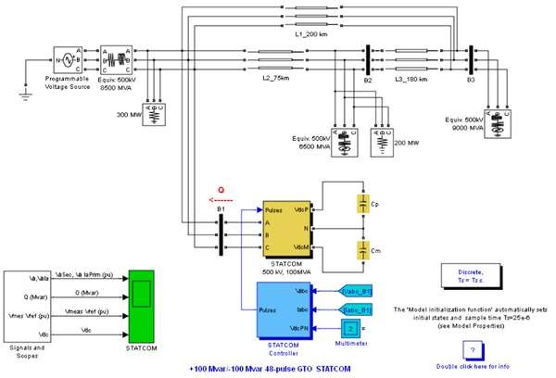
Fig:- demonstration of a +100 Mvar/-100 Mvar 48-pulse GTO STATCOM

Precaution :-

- Do not tamper with the settings of software.
- Study the all observations very carefully.

Procedure:-

Observation Table:-

Calculations:-

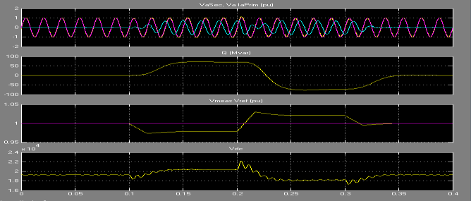
Result:-We have successfully demonstrate FACT devices for SMIB system. Output:-

References:-

- http://ir.inflibnet.ac.in:8080/jspui/bitstream/10603/9828/13/13_appendices.pdf
- http://people.eng.unimelb.edu.au/aldeen/PDF_Papers/CruscaAldeen_%20IJMSl_1995.

Viva voice Question:-

What is FACTS?

What is SMIB?

